The Intelligent Network

Information and Communication Design Principles
Richard A. Gershon, Ph.D.
Professor Emeritus, Western Michigan University
_______________________________

Gershon R.A. (2017). Digital Media and Innovation: Management and Design Strategies
in Communication. Thousand Oaks, CA: Sage. pp. 112-116.

The original idea of the web was that it should be a collaborative space where you can communicate through sharing information.
—Tim Berners-Lee

Introduction
International business has been transformed by the power of instantaneous communication. The combination of computer and telecommunications has collapsed the time and distance factors that once separated nations, people, and business organizations. This chapter will examine the subject of intelligent networking, which provides the technology and electronic pathways that makes global communication possible for small and large organizations alike. We start with the premise that the intelligent network is not one network but a series of networks designed to enhance worldwide communication for business and residential users.¹ What gives the network its unique intelligence are the people and users of the system and the value-added contributions they bring to the system via critical gateway points.
In this chapter, we introduce the Information and Telecommunications Systems (ITS) model as a way to explain a select number of network design principles. (See Figure 7.1.) Several examples of intelligent networking will be discussed, including telephony, cable television, and the Internet. Intelligent networks, by definition, presuppose permeable boundaries. that is, structured entry points that allow users to access and contribute to the overall system design. The same gateway points also mean opening up the system to any number of unwanted influences and outcomes. Accordingly, special attention is given to what I call the permeability predicament. A more detailed discussion of this will be considered later in this chapter.
The Intelligent Network Author’s Note: The information contained in this chapter is based on a monograph: Richard Gershon, “Intelligent Networks and International Business Communication: A Systems Theory Interpretation.”
Media Markets No. 12 (Pamplona, Spain: Universidad de Navarra Press, 2011).
Central to the discussion is that intelligent networks do not operate in a vacuum. Rather, the use of intelligent networks are part of a greater human and organizational decision-making process.² As Tim Berners-Lee (1999) points out, the Internet is as much a social creation as it is a technical one.³ While several of the terms listed in the ITS model are familiar to business and communication practitioners, they nevertheless provide an essential understanding of how intelligent networks operate. In sum, the combination of these network design elements and applications provide the structural basis for today’s information economy.

Figure 7.1 The Information and Telecommunications Systems Model

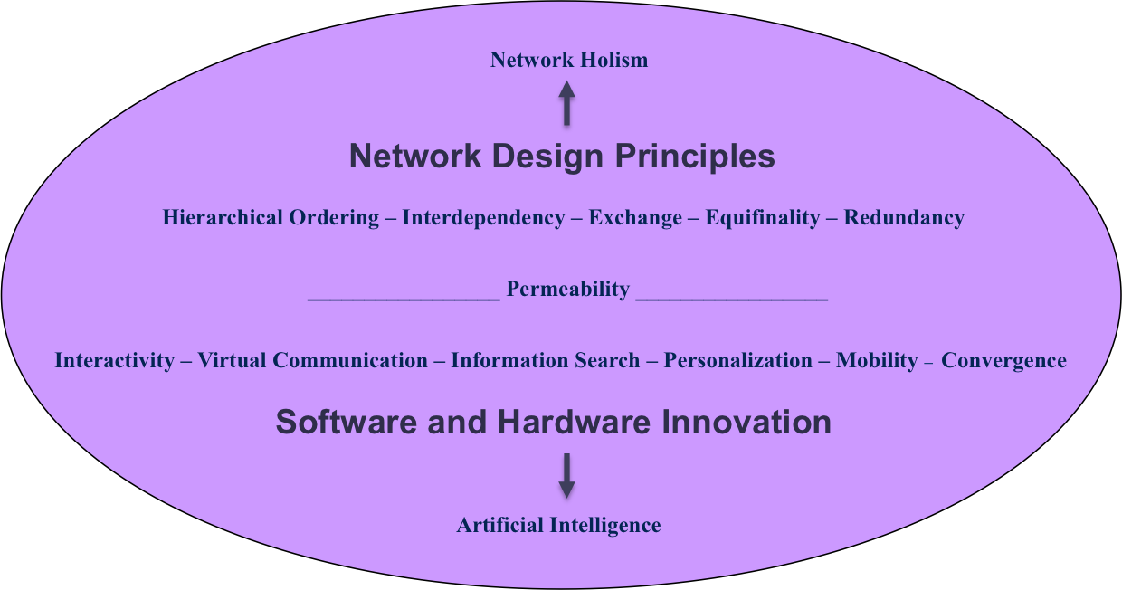
Source: R. Gershon (2015).
We begin by asking the following question. What makes an intelligent network intelligent? Specifically, what are the defining characteristics and features that comprise so-called intelligent networks? Special attention will be given to six key design principles. We will utilize the principles of systems theory as a way to look at the questions under investigation. The reason for selecting a systems theory approach is based on the assumption that intelligent networks (like human biology) do indeed function as integrated systems. Systems theory provides us with a distinct lens and labeling scheme that best accomplish this task.

The origins of systems theory can be traced to the fields of biology and engineering. One of the principal founders of the systems theory approach was Ludwig von Bertalanffy, a theoretical biologist. Bertalanffy published General Systems Theory in 1968 in which he argued that systems theory was equally appropriate for the social sciences as it was for biology.⁴ In the field of communication, systems theory was first adopted by Katz and Kahn (1966) in an influential work titled The Social Psychology of Organizations.⁵ In this book, the authors argue that organizations function as complex open systems that involve interaction among component parts as well as interaction with the environment.
Throughout the 1970s and 1980s, a great many researchers utilized systems theory as a way of understanding the relationship between organizational behavior and communication. Systems theory took on increasing importance as a way of explaining the principles of exchange, feedback, and interdependence, concepts that are fundamental to understanding the operations of a highly complex organization. Out of the systems theory tradition developed one theoretical approach known as network analysis.⁶ The goal of network analysis is to understand the process by which participants create and share information to reach a mutual understanding.⁷ Network analysis emphasizes the importance of human and organizational relationships as it defines the nature of the communication links between people, groups and organizations. To that end, we will adopt a select set of systems theory principles as a way to better explain the structures and substructures of intelligent networks and how they are used by business and individual users.⁸

Understanding Internal Structures and System Processes
Intelligence can be defined as the ability to reason, problem solve, think abstractly, comprehend complex ideas, and learn. Halal (1997) describes organizational intelligence as the “capacity of an organization to create knowledge and use it to strategically plan and adapt to its environment.”⁹ Intelligent networks, therefore, are the systems of communication that organize, transmit, and display information with the goal of improving organizational performance. Intelligent networks are also responsible for providing decision support and analysis. The intelligent network provides three levels of functionality as illustrated in Figure 7.2. They include: 1) Transmission, Display, and Storage; 2) Decision Support Analysis; and 3) Artificial Intelligence (AI).¹⁰

Figure 7.2 Intelligent Network: Three Level Hierarchy

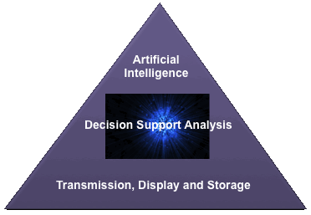
Source: R. Gershon (2015).

The first level can be described as Transmission, Display, and Storage (TDS). The role of the intelligent network is to provide the proper switching and routing of information between a sender and an intended audience. This can vary in size and complexity from a simple Skype video exchange to an international videoconference involving project teams from around the world. In both cases, the goal is to transmit information to an intended audience.
The second level can be described as Decision Support Analysis. Here the emphasis is on providing the user with critical information for purposes of information gathering, planning, designing, and decision making. The intelligent network is responsible for providing the organization and its users immediate access to a whole host of internal and external database services that might include investigating infectious diseases (i.e., U.S. Center for Disease Control and Prevention) or pursuing a criminal investigation of a suspected international terrorist (i.e., Interpol or U.S. Department of Homeland Security).
Depending on how the information is organized and sorted, there is an abundance of information that can provide the user with critical analysis capability.¹¹ The third level can be described as Artificial Intelligence (AI). The goal of the intelligent network is to make preprogrammed decisions. The network is designed to make recommendations to the user and/or take corrective action based on established algorithms. Once again, examples can vary in size and complexity starting with a proprietary software recommendation system built by EC companies like Amazon, Netflix, and Apple. Such companies make personalized product recommendations (i.e., books, films, and music) via their EC Web sites based on past selections. At a more complex level, AI refers to pre-programmed decision making. As an example, modern aviation relies on an automated flight control management system to control the aircraft. The flight control system can control and automate all phases of a flight operation, including takeoff and ascent, flight guidance (autopilot), descent, approach, and landing. Part of the built-in AI capability is a Traffic Alert and Collision Avoidance System (TCAS), which is designed to reduce the incidence of midair collisions between aircraft. The TCAS monitors an aircraft’s surrounding airspace and warns pilots of the presence of other planes and jets in the vicinity.

Four Working Assumptions about Intelligent Networks
When engineers discuss the architecture of a network, they are describing how the physical parts of the network are organized, including: 1) Information Pathways (network configurations), 2) Terminals (computers, smartphones, etc.), 3) Software (applications and protocols), and 4) Data Enhancement Equipment (modems, laser printers, Wi-Wi, etc.). First, as noted earlier, the intelligent network is not one network but a series of networks designed to enhance worldwide communication for business and individual users alike.¹² Second, what gives the network its unique intelligence are the people and users of the system and the value-added contributions they bring via critical gateway points. Today, the Internet has grown exponentially in size and complexity due to the many contributions of its users, ranging from powerful search engines to unique Web site design as well as the aggregation of content.
A third assumption is that intelligent networks do not operate in a vacuum. Rather, the use of intelligent networks are part of a greater human communication and organizational decision-making process.¹³ Nowhere is this more evident than in the creation of enterprise resource planning (ERP) and just in time manufacturing (JITM) networks designed to aid business process as discussed in Chapter 4. And fourth, as intelligent networks grow and evolve, they often exhibit self-learning qualities in what can be described as network evolution.¹⁴ This is a crucial element in helping to explain what makes an intelligent network intelligent. More decidedly, it speaks to the importance of AI. According to the ITS model, there are six key essential parts that comprise intelligent network design. They include:
1) Hierarchical Ordering, 2) Interdependency, 3) Exchange, 4) Equifinality, 5) Redundancy, and 6) Network Holism.

