Freedom of Expression
Affinity Groups: Select Examples
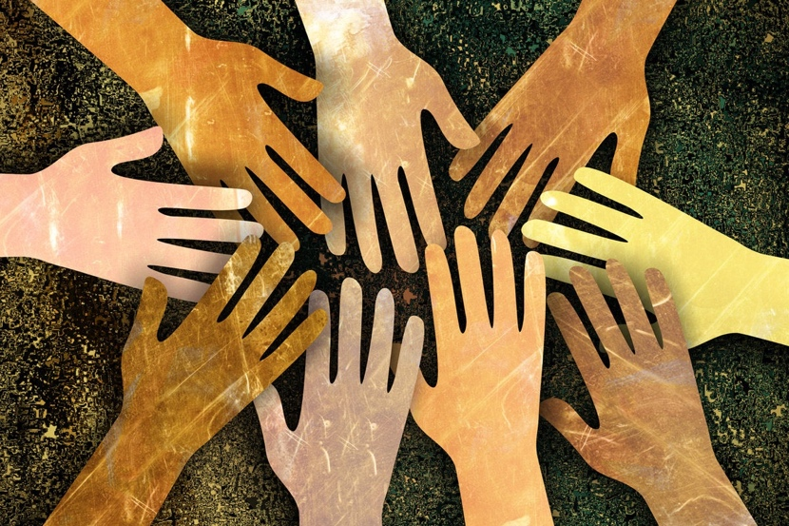
______________________________________________________________________________

Academic/Scholarship
American Historical Association
https://www.historians.org/

Association for Education in Journalism and Mass Communication
https://www.aejmc.org/

Brookings Institution
https://www.brookings.edu/

International Communication Association
https://www.icahdq.org/

Black Civil Rights
Black Lives Matter
https://blacklivesmatter.com/

NAACP (National Association for the Advancement of Colored People)
https://naacp.org/

National Coalition on Black Civic Participation
https://www.ncbcp.org/

Criminal Justice Reform
The Innocence Project
https://innocenceproject.org/

The Sentencing Project
https://www.sentencingproject.org/

First Amendment, Personal Rights and Freedoms
American Civil Liberties Union
https://www.aclu.org/

Cato Institute
https://www.cato.org/

Heritage Foundation
https://www.heritage.org/

Ifex (International Freedom of Expression)
https://ifex.org/

National Coalition Against Censorship
https://ncac.org/

Hate Speech / Hate Groups
OSCE – Hate Crime Reporting
https://hatecrime.osce.org/

Southern Poverty Law Center
https://www.splcenter.org/

Lesbian, Gay, Bisexual and Transgender Rights
Gender Spectrum
https://www.genderspectrum.org/

Human Rights Campaign
https://www.hrc.org/

National Center for Lesbian Rights (NCLR)
https://www.nclrights.org/

U.S. Immigration Reform
Black Alliance for Just Immigration
https://baji.org/

Catholic Legal Immigration Network, Inc.
https://cliniclegal.org/

Center for Immigration Studies
https://cis.org/

Women’s Right’s Issues
Center for Reproductive Rights
https://reproductiverights.org/

National Organization for Women
https://now.org/

UN Women
https://www.unwomen.org/en

